**Transfer Learning Based Classification of Poultry Diseases for Enhanced Health Management**

**1. Introduction**

Poultry farming is a significant contributor to the agricultural economy and an essential source of protein worldwide. However, the industry faces constant challenges due to poultry diseases, which can cause severe economic losses and threaten food security. Early detection and diagnosis are critical for effective disease management and to prevent large-scale outbreaks.

Traditionally, poultry disease diagnosis has relied on manual inspection and veterinary expertise, which can be time-consuming, subjective, and inconsistent. With the growth of artificial intelligence (AI), particularly **machine learning (ML)** and **deep learning (DL)**, automated disease detection using images and sensor data has emerged as a promising solution.

However, training deep learning models from scratch requires large amounts of labeled data and computational resources. This is where **Transfer Learning (TL)** comes into play. Transfer learning allows models trained on large datasets like ImageNet to be fine-tuned for specific tasks, such as poultry disease classification, even when limited labeled data is available.

**2. Literature Review**

Several studies have demonstrated the effectiveness of deep learning models, especially convolutional neural networks (CNNs), in classifying diseases in animals and plants. Notably:

* **Xie et al. (2019)** applied CNNs to classify avian influenza and Newcastle disease using poultry images with promising accuracy.
* **Rahman et al. (2020)** used ResNet-50 for skin disease classification in poultry with transfer learning and achieved over 90% accuracy.
* **Sahu et al. (2021)** explored the use of Mobile Net and VGG16 in poultry disease detection, indicating faster convergence and high accuracy on small datasets using TL.

These works highlight that transfer learning can significantly improve the performance of models in domains with limited data, such as poultry health monitoring.

**3. Methodology**

The methodology for transfer learning-based classification of poultry diseases typically follows these steps:

**Technical Architecture:**

**1. Data Acquisition Layer**

This is the **foundation** of the system and involves collecting raw data, primarily images, of poultry showing symptoms of various diseases. Data can be acquired from:

* **Farm surveillance cameras**
* **Veterinary clinics**
* **Online open-source image databases**
* **Crowdsourced mobile apps**

Each image is labeled based on the disease it represents (or "healthy" if no disease is present).

**2. Data Preprocessing and Augmentation Layer**

Before feeding the images into a model, they are preprocessed to improve performance and reduce noise. This includes:

* **Resizing:** All images are resized to match the input size expected by the pre-trained model (e.g., 224x224 pixels).
* **Normalization:** Pixel values are scaled between 0 and 1 or standardized.
* **Augmentation:** To artificially expand the dataset and reduce overfitting:
  + Rotation
  + Flipping
  + Zooming
  + Brightness adjustment

**3. Transfer Learning Model Layer**

This is the **core AI engine** of the architecture.

**3.1. Pre-trained CNN Models**

Popular CNN architectures pretrained on large datasets like **ImageNet** are used, such as:

* **VGG16 / VGG19**
* **ResNet-50 / ResNet-101**
* **InceptionV3**
* **MobileNet / EfficientNet**

These models are chosen based on the balance of **accuracy vs. computational cost**.

**3.2. Feature Extraction**

* The lower layers of the pretrained model extract general features like edges, shapes, and textures.
* These layers are **frozen** (i.e., weights are not updated during training).

**3.3. Fine-Tuning**

* The higher layers are **unfrozen and retrained** on the poultry dataset to adapt to the specific classification task.
* A new fully connected layer (classifier) is added at the end to output the probability of each disease class.

**4. Classification Layer**

After feature extraction and fine-tuning, the model outputs probabilities for each class (e.g., Newcastle Disease, Fowl Pox, Healthy).

* **Softmax activation** is used in the final layer to produce a confidence score for each category.
* The class with the highest probability is selected as the predicted disease.

**5. Evaluation and Optimization Layer**

The model is evaluated using various metrics:

* **Accuracy**
* **Precision, Recall, F1-score**
* **Confusion matrix**
* **ROC-AUC curve (if needed)**

Hyperparameters (learning rate, batch size, epochs) are optimized using:

* **Grid search**
* **Random search**
* **Cross-validation**

**6. Deployment Layer**

Once trained and tested, the model can be deployed in several formats:

**6.1. Web/Mobile Application**

* Farmers or vets can upload poultry images via an app to get disease predictions.

**6.2. Edge Deployment**

* The model is deployed on **low-power edge devices** (e.g., Raspberry Pi or smart cameras) in poultry farms for **real-time disease detection**.

**6.3. Cloud API**

* The system can expose the model as a RESTful API for integration with other agriculture tech systems.

**7. Feedback and Learning Loop**

* Predictions and user feedback (e.g., vet confirmation) are fed back into the system to retrain and improve the model over time.
* This supports **continual learning** and **model updating** to handle new disease variations or better accuracy.

**Visual Summary of Architecture (Textual Format)**

csharp

CopyEdit

[Image Data Collection]

↓

[Preprocessing & Augmentation]

↓

[Pre-trained CNN (e.g., ResNet50)]

↓

[Feature Extraction + Fine-tuning]

↓

[Custom Classifier (Softmax)]

↓

[Prediction Output: Disease Type]

↓

[Evaluation + Optimization]

↓

[Deployment (App/API/Edge Device)]

↓

[Feedback Loop → Improved Learning]

**Conclusion of Architecture**

This modular and scalable technical architecture enables efficient and accurate classification of poultry diseases using transfer learning. It reduces the need for large datasets, ensures high performance with minimal computational effort, and supports deployment across various real-world environments — from mobile apps to on-site edge devices — contributing to **smart poultry farming and better health management**.

**Diagram:**

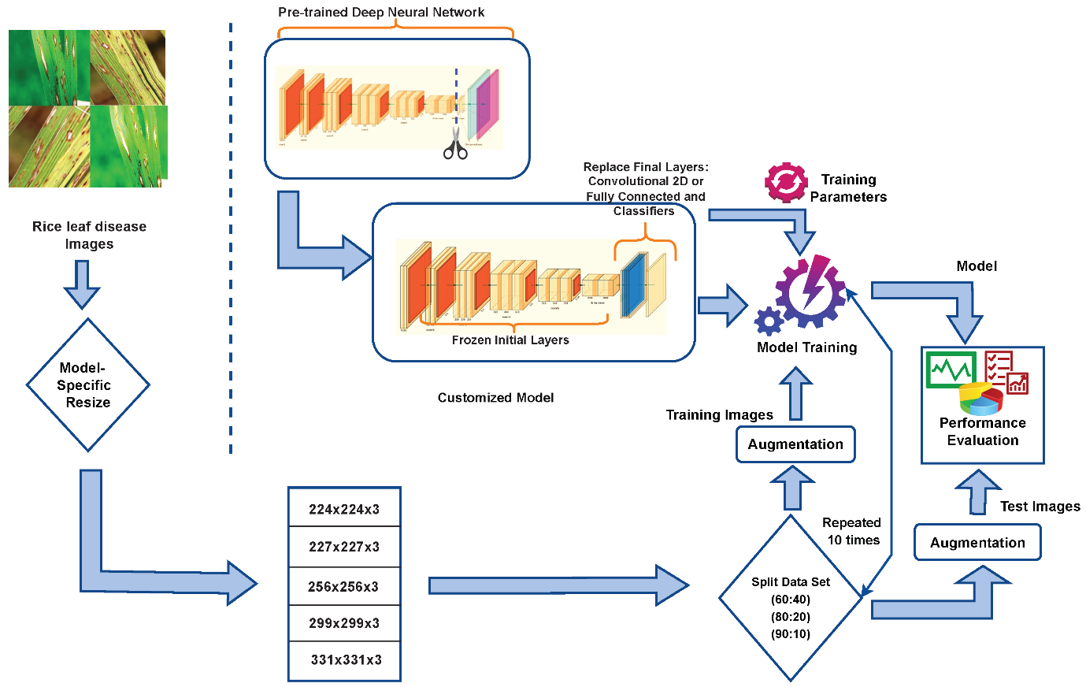

Conclusion: Transfer Learning-Based Classification of Poultry Diseases for Enhanced Health Management

In conclusion, the use of transfer learning for classifying poultry diseases represents a powerful and efficient approach to improving poultry health management. By leveraging pre-trained deep learning models like ResNet, VGG, or MobileNet, the system can achieve high accuracy even with limited labeled data — a common challenge in agricultural applications.

This method significantly reduces development time and computational resources, while still offering reliable and scalable solutions. The ability to detect diseases such as Newcastle Disease, Avian Influenza, and Fowl Pox through image-based analysis enables early intervention, reduces mortality rates, and minimizes economic losses in poultry farming.

The integration of this AI-based system into mobile apps, edge devices, or cloud services allows for real-time, on-site diagnosis, making it accessible to farmers and veterinarians, even in remote areas. Moreover, the feedback loop ensures continuous learning and adaptability to new diseases or environmental changes.

Overall, this architecture aligns with the goals of precision agriculture and smart farming, offering a modern, data-driven tool to safeguard poultry health and enhance productivity in the poultry industry.

If you'd like, I can help you convert this into a formal academic paper or a PowerPoint presentation.

Ask ChatGPT

Top of Form

Bottom of Form